SURVEYKSHAN

project Understanding Document

VERSION 1.0
28-06-2017

VERSION HISTORY

Version # | Implemented  By | Revision  Date | Approved  By | Approval  Date | Reason
1.0 | Amandeep Rikhi, Nancy Hada, Ritu Gaba, Shubham Gosain, Umang Gupta | <07/05/2017> | <name> | <mm/dd/yy> | <reason>

TABLE OF CONTENTS
1 introduction 4
1.1 Purpose of Project 4
2 project And Product Overview 4
3 Scope 4
3.1 Objectives 4
3.2 High-Level Requirements 5
3.3 Business Rules and Special considerations 5
3.4 Major Deliverables/Milestones 5
4 Duration 5
4.1 Timeline 5
6 project understanding approval 6

introduction

Many desktop application claim to provide a good survey engine. The different desktop application functioning now a days promise their user’s (the registered ones) to provide them with limited surveys. There is no way to generate reviews about how the survey is going on. The users can go through the surveys which are held on limited issues.

Also, there exist no way that User may give views about the surveys. However, these reviews hold a high opinion for other new users who want to join the portal.

If any user want to create his/her own survey on any random topic then these portals can’t be able to provide this facility to the registered users.

SURVEYKSHAN is a user friendly desktop based application which provides solution to all these above stated problems from providing one-stop solution to provision of creating surveys by the users and any user can go through different types of surveys which are going on.

Purpose of Project
As stated above the sole aim of this project is to create surveys and fill surveys by the users at reasonable price, provide a one stop solution to the problems of the users.

The main purposes of this project are:-

- To provide a list of available surveys to the searching User.
- To provide them with the ability of creating their own surveys.
- To charge a nominal fees depending upon the payment to be made for creating and filling surveys.
- To provide authentic ways to the admin for updating user’s details and receiving payments.
- To promote new surveys.

Benefits of the Project:

Cost
Surveys are relatively inexpensive. Online surveys and mobile surveys, in particular, have a very small cost per respondent. Even if incentives are given to respondents, the cost per response is often far less than the cost of administering a paper survey or phone survey, and the number of potential responses can be in the thousands.

Extensive
Surveys are useful in describing the characteristics of a large population. No other research method can provide this broad capability, which ensures a more accurate sample to gather targeted results in which to draw conclusions and make important decisions.

Flexible
Surveys can be administered in many modes, including: online surveys, email surveys, social media surveys, paper surveys, mobile surveys, telephone surveys, and face-to-face interview surveys. For remote or hard-to-reach respondents, using a mixed mode of survey research may be necessary (e.g. administer both online surveys and paper surveys to collect responses and compile survey results into one data set, ready for analysis).

Dependable
The anonymity of surveys allows respondents to answer with more candid and valid answers. To get the most accurate data, you need respondents to be as open and honest as possible with their answers. Surveys conducted anonymously provide an avenue for more honest and unambiguous responses than other types of research methodologies, especially if it is clearly stated that survey answers will remain completely confidential.

project And Product Overview
SURVEYKSHAN is a user friendly desktop based application which provides solution to all these above stated problems from providing one-stop solution to provision of creating surveys by the users and any user can go through different types of surveys which are going on.
With a simple registration, User can find good, reliable surveys at reasonable price and new surveys are promoted by the Admin. We keep updating the users with news of different surveys.

The SURVEYKSHAN can be divided into two modules, namely:

Module 1: Site Administrator
This module is responsible for maintaining the overall system based on defined business rules and it performs the following functions:
- It can delete user.
- It can modify the user details.
- It can update application details.
- It can receive payments.

Module 2: User
This module will allow different users to get access through the software and it performs the following functions:

    - Register to the survey.
    - It can create his/her own survey.
    - It can fill any survey.
    - It can update details.
    - Checking for payments.

Scope

Objectives

- The new user must register with the application before availing any services from it.
- For each registration maintain the record in the database for the new user.
- For each new registration a profile is to be created. It will contain basic details of the user.
- When searching for the surveys by the User, their need for filling the surveys is the key area of concern.
- When the user wants to create a new survey, he/she has to fulfill the requirements for creating it.
- The payment could be done through virtual coins.

High-Level Requirements
The following table presents the requirements that the project’s product, service or result must meet in order for the project objectives to be satisfied.
Req. # | I Requirement Description
Registration | To Provide complete access to the users i.e.to become a valid user.
Transaction | Details of valid transaction are retrieved.
Creating Survey | User can create his/her surveys for a limited period of time.
Filling Survey | Any User can fill different surveys after meeting the requirements  which are needed.

Business Rules and Special considerations

- Users are eligible to go through different surveys only as long as their membership is valid and in good standing.
- Users are eligible to create their own surveys and enjoy the membership i.e., to be constantly updated, to access resources until his/her membership is valid.
- Access will be provides within allotted time period after which payment has to be done again. In exceptional cases the administrator has the rights to take any actions if necessary.
- Any anonymous user to avail resources from the portal has to become a registered user.
- The user should have a valid email-id, postal address to register.
- No transaction is eligible for cash back.

Major Deliverables/Milestones
[Provide a list of the major deliverables/milestones that will be completed by the end of this project. A deliverable is any unique and verifiable product, result or capability to perform a service that must be produced in order to complete a process, phase or project. A milestone is a key performance indicator that is typically reported to executives to indicate the project’s progress.]
Major Deliverable | I Deliverable Description

Duration

Timeline
[Provide an estimate of the project duration (e.g., 18 months). You may provide a high-level timeline for the project if information is available at this time. This time estimate will be further refined in the Planning Phase of the project. If applicable, also state the expected life of the product. An example of a high-level timeline is provided below.]

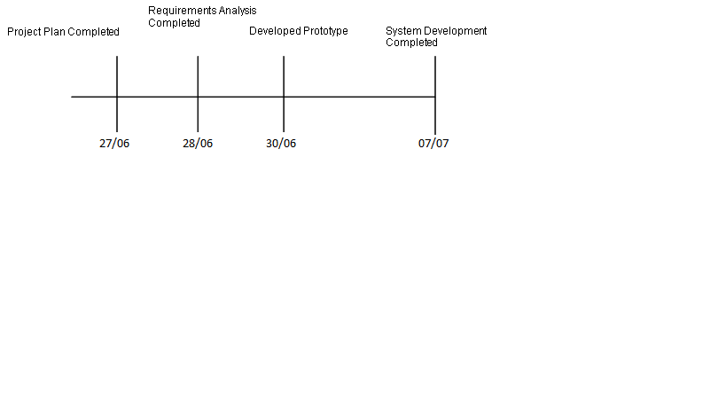

project understanding approval
The undersigned acknowledge they have reviewed the Project Understanding Document for the SURVEYKSHAN project. Changes to this document will be coordinated with and approved by the undersigned or their designated representatives.
[List the individuals whose signatures are desired. Examples of such individuals are Business Steward, Project Manager or Project Sponsor. Add additional lines for signature as necessary. Although signatures are desired, they are not always required to move forward with the practices outlined within this document.]
Signature: |  | Date:
Print Name: | AMANDEEP RIKHI
Title:
Role:

Signature: |  | Date:
Print Name: | NANCY HADA
Title:
Role:

Signature: |  | Date:
Print Name: | RITU GABA
Title:
Role:

Signature: |  | Date:
Print Name: | SHUBHAM GOSAIN
Title:
Role:

Signature: |  | Date:
Print Name: | UMANG GUPTA
Title:
Role:

APPENDIX A: REFERENCES
[Insert the name, version number, description, and physical location of any documents referenced in this document. Add rows to the table as necessary.]
The following table summarizes the documents referenced in this document.
Document Name and Version | Description | Location
Project Understanding and Version 1.0 | This document gives the required information on the project.

APPENDIX B: KEY TERMS

The following table provides definitions for terms relevant to this document.
Term | Definition
Authentic | Valid things, refers to the truthfulness of origins, attributions and commitment.
Virtual Coins | A type of unregulated, digital money, which is issued and usually controlled by its developers, and used and accepted among the members of a specific virtual community.

